**Database Design**

**Veterinary Management System**

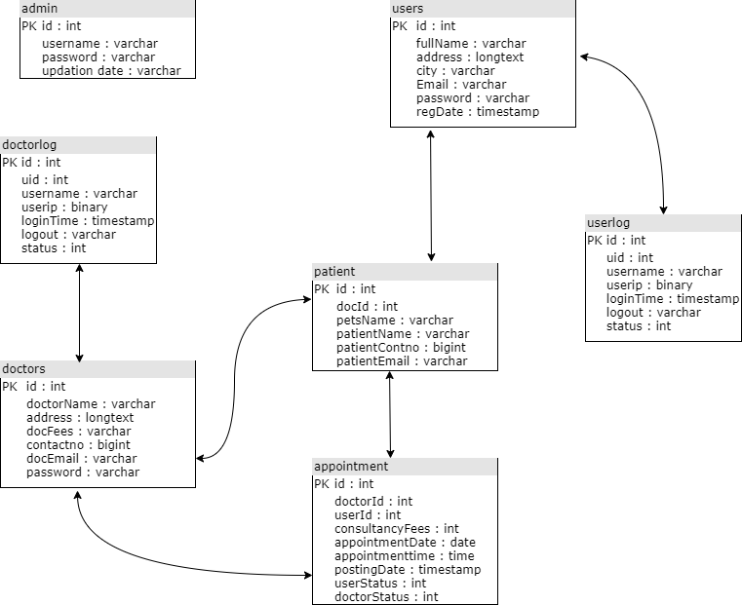

**Table Design**

**Veterinary Management System**

**1.Admin Table**

|  |  |  |  |
| --- | --- | --- | --- |
| **Name** | **Type** | **Constraint** | **Description** |
| Id | Int | Primary key | Admin id |
| Username | Varchar |  | Admin name |
| Password | Varchar |  | Admin password |
| Updationdate | Varchar |  | Updation date |

**2.Appointment Table**

|  |  |  |  |
| --- | --- | --- | --- |
| **Name** | **Type** | **Constraint** | **Description** |
| Id | Int | Primary key | Admin id |
| Doc_id | Int |  | Doctor id |
| User_id | int |  | User id |
| Con_fees | int |  | Doctor Consultancy Fee |
| App_date | Varchar |  | Appointment Date |
| App_time | Varchar |  | Appointment Time |
| Postingdate | Timestamp |  | Appointment Posting Date |
| Userstatus | Int |  | User status |
| Doctorsatus | Int |  | Doctor status |

**3. Doctor Table**

|  |  |  |  |
| --- | --- | --- | --- |
| **Name** | **Type** | **Constraint** | **Description** |
| Id | int | Primary key | Doctor id |
| Doc_name | Varchar |  | Doctor name |
| Address | Longtext |  | Doctor address |
| Doc_fees | Varchar |  | Doctor fee |
| Contact_no | Bigint |  | Doctor contact no |
| Doc_email | Varchar |  | Doctor email |
| Password | Varchar |  | Doctor password |

**4.Patient Table**

|  |  |  |  |
| --- | --- | --- | --- |
| **Name** | **Type** | **Constraint** | **Description** |
| Id | Int | Primary key | Patient id |
| Doc_id | Varchar |  | Doctor id |
| Pet_name | Varchar |  | Pets name |
| Patient_name | Varchar |  | Patient_name |
| Patient_contno | Bigint |  | Patient contact no |
| Patient_email | Varchar |  | Patient email |

**5.User Table**

|  |  |  |  |
| --- | --- | --- | --- |
| **Name** | **Type** | **Constraint** | **Description** |
| Id | Int | Primary key | User id |
| Name | Varchar |  | User name |
| Address | Longtext |  | User address |
| City | Varchar |  | User city |
| Email | Varchar |  | User email |
| Password | Varchar |  | User password |
| Reg_date | timestamp |  | User register date |

**6.Userlog Table**

|  |  |  |  |
| --- | --- | --- | --- |
| **Name** | **Type** | **Constraint** | **Description** |
| Id | Int | Primary key | Userlog id |
| Uid | Int |  | User id |
| Username | Varchar |  | User user name |
| Userip | Binary |  | User ip address |
| Logintime | Timestamp |  | User login time |
| Logout | Varchar |  | User logout time |
| Status | Int |  | User status |

**7.Doctorlog Table**

|  |  |  |  |
| --- | --- | --- | --- |
| **Name** | **Type** | **Constraint** | **Description** |
| Id | Int | Primary key | Doctorlog id |
| Doc_id | Int |  | Doctor id |
| Username | Varchar |  | Doctor username |
| Doc_ip | Binary |  | Doctor ip address |
| Logintime | Timestamp |  | Doctor login time |
| Logout | Varchar |  | Doctor logout time |
| Status | Int |  | Doctor status |

**Database Design**

**Petshop Management System**

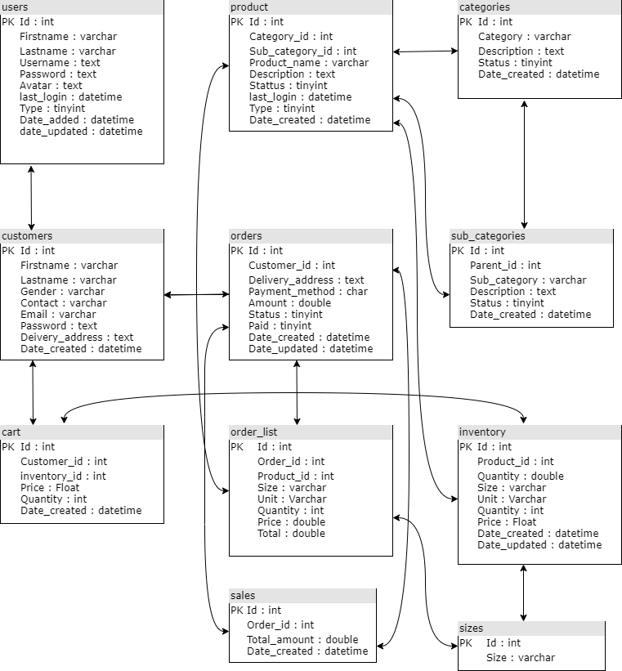

**Table Design**

**Petshop Management System**

**1.User Table**

|  |  |  |  |
| --- | --- | --- | --- |
| **Name** | **Type** | **Constraint** | **Description** |
| Id | Int | Primary key | User id |
| First_name | Varchar |  | User first name |
| Last_name | Varchar |  | User last name |
| User_name | Text |  | User username |
| Password | Text |  | User password |
| Avatar | Text |  | User avatar |
| Last_login | Datetime |  | User last_login |
| Type | Tinyint |  | User type |
| Date_added | Datetime |  | User date_added |
| Date_updated | Datetime |  | User date_updated |

**2.Customer Table**

|  |  |  |  |
| --- | --- | --- | --- |
| **Name** | **Type** | **Constraint** | **Description** |
| Id | Int | Primary key | Customer id |
| First_name | Varchar |  | Cust first name |
| Last_name | Varchar |  | Cust last name |
| Gender | Varchar |  | Customer gender |
| Contact | Varchar |  | Customer contact |
| Email | Varchar |  | Customer email |
| Password | Text |  | Customer password |
| Delivery_address | Text |  | Delivery address |
| Date_created | Datetime |  | Date created |

**3. Cart Table**

|  |  |  |  |
| --- | --- | --- | --- |
| **Name** | **Type** | **Constraint** | **Description** |
| Id | Int | Primary key | Cart id |
| Customer_id | Int |  | Customer id |
| Inventory_id | Int |  | Inventory id |
| Price | Float |  | Product price |
| Quantity | Int |  | Product quantity |
| Date_created | Datetime |  | Date created |

**4.Product Table**

|  |  |  |  |
| --- | --- | --- | --- |
| **Name** | **Type** | **Constraint** | **Description** |
| Id | Int | Primary key | Product id |
| Category_id | Int |  | Category id |
| Sub_category_id | Int |  | Sub category id |
| Product_name | Varchar |  | Product name |
| Description | Text |  | Product description |
| Status | Tinyint |  | Product status |
| Last_login | Datetime |  | Product last_login |
| Type | Tinyint |  | Product type |
| Date_created | Datetime |  | Date created |

**5.Order Table**

|  |  |  |  |
| --- | --- | --- | --- |
| **Name** | **Type** | **Constraint** | **Description** |
| Id | Int | Primary key | Order id |
| Customer_id | Int |  | Customer id |
| Delivery_address | Text |  | Delivery address |
| Payment_method | Char |  | Payment method |
| Amount | Double |  | Order Amount |
| Status | Tinyint |  | Order status |
| Paid | Tinyint |  | Order paid |
| Date_created | Datetime |  | Order created date |
| Date_updated | Datetime |  | Order updated date |

**6.Order list Table**

|  |  |  |  |
| --- | --- | --- | --- |
| **Name** | **Type** | **Constraint** | **Description** |
| Id | Int | Primary key | Order list id |
| Order_id | Int |  | Order id |
| Product_id | Int |  | Product id |
| Size | Varchar |  | Product size |
| Unit | Varchar |  | Order unit |
| Qunantity | Int |  | Order quantity |
| Price | Double |  | Order price |
| Total | Double |  | Order Total price |

**7.Sales Table**

|  |  |  |  |
| --- | --- | --- | --- |
| **Name** | **Type** | **Constraint** | **Description** |
| Id | Int | Primary key | Sales id |
| Order_id | Int |  | Order id |
| Total_amount | Double |  | Sales total amount |
| Date_created | Datetime |  | Sales created date |

**8.Categories Table**

|  |  |  |  |
| --- | --- | --- | --- |
| **Name** | **Type** | **Constraint** | **Description** |
| Id | Int | Primary key | Category id |
| Category | Varchar |  | Category name |
| Description | Text |  | Category description |
| Status | Tinyint |  | Category status |
| Date_created | Datetime |  | Category date_created |

**9.Sub category Table**

|  |  |  |  |
| --- | --- | --- | --- |
| **Name** | **Type** | **Constraint** | **Description** |
| Id | Int | Primary key | Sub category id |
| Parent id | Int |  | Category id |
| Sub_category | Varchar |  | Sub category name |
| Description | Text |  | Sub category description |
| Status | Tinyint |  | Sub category status |
| Date_created | Datetime |  | Sub category created date |

**10.Inventory Table**

|  |  |  |  |
| --- | --- | --- | --- |
| **Name** | **Type** | **Constraint** | **Description** |
| Id | Int | Primary key | Inventory id |
| Product id | Int |  | Product id |
| Quantity | Double |  | Product quantity |
| Size | Varchar |  | Product size |
| Unit | Varchar |  | Product unit |
| Price | Float |  | Product price |
| Date_created | Datetime |  | Inventory date created |
| Date_updated | Datetime |  | Inventory date updated |

**11.Size Table**

|  |  |  |  |
| --- | --- | --- | --- |
| **Name** | **Type** | **Constraint** | **Description** |
| Id | Int | Primary key | Size id |
| Size | Varchar |  | Order size |
|  | | | |

Submitted By:

Adarsh s

Mca – A

AJCMCA - 2003

Submitted To:

Merin Miss